Name: Gerardo Gonzalez

Date: 2024/2/1

SNHU: CS-360

The app that I have chosen to recreate is the Five Guys app. Based on my research on this app I found that the menu section could be improved to provide a more users friendly experience.

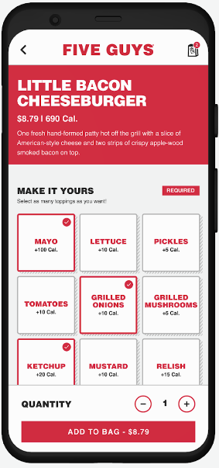Stock app layout evaluation.

When I first examined the layout I found that as a user the menu selection could be improved to have a more simple approach to the selection process.

Upon further the user app's description could also benefit from including what the food item will look like. This benefits the users as for this application the user can be influenced based on how the food item looks.

Revised Version.

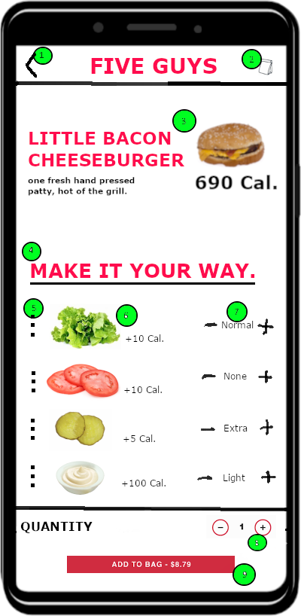

Here we can see the indicator next to all the UI elements. The changes would improve how the application operates and how the data is presented to the users. In this situation, I have decided to color the indicators green.

Indicators

1. Here we have a navigational component, this is the same as the stock design of this server for a user to navigate back to the home page. This element is interactive this back button triggers an activity in a way that the users can use to navigate back to the home screen.
2. This interactive icon can be accessed at the back, it allows the user to navigate to the bag activity screen where the users would pay for the food. This element could be improved by having a visual display of how many items are in the back. In this example, I choose not to incorporate that indication due to all the indicators that are present. This UI element serves both as a navigational and informative component in the system.
3. For this indicator we have a non-interactive UI element, this element is an informative component for the system and it works by displaying the item that the user is modifying before adding to the cart. Some information that is included here is an image of the food item, the name of the product, a small description, and how many calories the food item has.
4. The fourth indicator shows us another non-interactive UI element, this informative component displays an instructive message so the user knows what this activity offers. Which is to add ingredients to the food item, which is described below and broken down into three main indicators.
5. The fifth indicator is an interactive UI element in the form of a menu selection. If selected the users can have specialty instructions, such as having the ingredients as a side if they wish to do so.
6. The sixth indicator shows us what ingredient this applies to, this is a non-interactive component, serves as an informational element, and displays how many calories the users can expect that be added to the order.
7. The seventh indicator is an interactive UI component, which lets the user select the amount of ingredients that the users can add to the order. This also element has features that are informative as well, which shows how much is added to the order.
8. Similarly the eighth indicator shows an interactive component, this UI element is informative and also shows a number that users can add to or subtract. The data here is to the quantity of items this modification applies to, an example is to have two bacon cheeseburgers with pickles.
9. Finally the ninth element is a button which is an interactive component, and displays a message to the users along with the amount that is being added to the “bag”

Justification.

1. This is added so that users have a convenient way to navigate back to the home or previous page.
2. This component is not changed from the original similar to the back button because it already provides a convenient way for the users to navigate to a different screen in the app, in this case, the bag section.
3. This design change allows the users to not only see the previous description but also an image of what the user will be getting. This improves the data interpretation at a glance as the user will be searching on what to eat and targets the audience that like to know what the food looks like before they make a decision.
4. No change same as before just in a different style, the importance of this design is to instruct the user that they can modify the food item to their liking.
5. This improves the UI design by having a special instruction that some users will most likely would like.
6. Similarly, to the design element in the product title, it shows an image of what is being selected, in this case, the ingredient item and this benefits the user by offering a quick visual indicator briefly.
7. This design element lets the user control how much of an ingredient would be added to the food item. The benefit of implementing this UI design element is that the user can control their order and conveniently view data.
8. This benefits the user by having control over the quantity of items to add, the idea for this UI design update was to similarly capture what the stock app does, which is to let the user address multiple items of the same ingredients in one activity.
9. This was not changed as I found that no update was needed.